INDUSTRIAL POWER ANALYSER
Made in Australia by:
PATON ELECTRICAL PTY. LTD.
ASHFIELD, N.S.W.

The Paton Industrial Power Analyser is a Self-Contained Alternating Current Instrument, capable of comprehensive testing and power analysis of 3 Phase 3 Wire also Single Phase Circuits.
All Instruments. Selector Switches, Current and Potential Transformers. are integrally mounted and wired to cover the Ranges listed below.

GENERAL SPECIFICATIONS
Circuits 3 Phase, 3 Wire, Balanced and Unbalanced Load. also Single Phase.
ALTERNATING CURRENT ONLY

MEASUREMENTS:
3 Phase -Volts. Amperes, Watts, Phase Angle & Phase Sequence.
Single Phase:-Volts, Amperes & Watts (Power Factor by Calculation).

Ratings
Potential: 150, 300 and 600 Volts A.C.
Current:: 5, 25,125 Amperes A.C.
Frequency: 25 to 150 Cycles A.C.
Power Factor: 0 to Unity Lead and Lag Power Factor (cos Ø)
Phase Angle: 0/360 Degrees of Lag
Phase Sequence: ABC/CBA
Accuracy: Amperes and Volts ±1.5%FSD.
Watts ±2% FSD.

INSTRUMENTS:
Voltmeter: Ranges 01150,300, 600 Volts A.C
Ammeter: Ranges 0/5.25. 125 Amperes A.C.
Power Factor: Zero to Unity Power Factor (cos Ø).
Meter: Lead and Lag in 4 Quadrants.
0/360 Electrical Degrees of Lag of Current behind Voltage.
Wattmeter: 2 Element Electro-Dynamic 0/1 KW. to, 0/100 KW 3 Phase 3 Wire Balanced and Unbalanced Load (0/0.5 KW. to 0/50 KW. Single Phase). in 18 Ranges according to Voltage and Current Ratings.
Phase Sequence Moving Coil Rectifier Type, Horizontal Indicator: Edgewise.
Clear Plastic Case.

The Paton Industrial Power Analyser is designed purely for A.C. operation only and MUST NOT be connected to Direct Current under any circumstances.
With Voltage only applied. the Power Factor Meter may rotate slowly This is quite normal and will cease immediately a load is applied.

CAUTION Connecting Leads must be of adequate sectional area for the current values concerned in the connections to and from A and C Phase Terminals Thee connections of 'the B (or Yellow) Phase need only be of low Section (e.g., % Amp Rating). Terminals should be thoroughly tightened to avoid burning due to high resistance contacts. As high powered circuits may be involved, extreme care should be exercised to avoid possible short circuits, etc.
Where the Voltage and/or Current values of the circuit are not known, it is advisable to make use of the higher ranges and after determining the approximate values, then, if necessary, to apply the lower and more appropriate range.
In event of connection to a circuit of higher voltage than the range selected a Potential Fuse may become blown. Non-Indication by the Voltmeter will indicate the Phase concerned as indication by the Voltmeter inter-phase Switch. The Fuse should be replaced from the set of spare fuses provided In the lid compartment. Access to the Potential Fuses for replacement is made by unscrewing the knurled caps.
After replacement of Fuse, we would stress the necessity for care in selecting the Voltage Range.

OPERATIONS

3 Phase 3 Wire Circuits. Connect the I.P.A. according to Diagram. No 1 with ''Load'' side. Terminals selected according to the expected current loading of circuit (N.B. for Motor Current Loading – see Table A)

It is essential to use connecting leads of adequate section far the particular current rating in use. The connection to the ''B'' or Yellow central Phase terminal need be of low sectional area as potential loading only is. connected to this Phase.

Turn Potential Selector Switch to the appropriate Phase to Phase Voltage position (600 V. position for 415 V. and 440 V. circuit 300 V. position for 240 V. - 150 V. position for 110 V. and PT. Secondary Circuits, etc.), see Diagram 4.

Leaving the Ammeter Phase Selector Switch in the Off Position, the load may now be switched on.

Please note the correct Phase Sequence Indication. If indication is C-B-A Reverse. then it is necessary to transpose the A and C Phase Connections.

The Ammeter Phase Selector Switch may now be rotated to the A, B or C Phase position at which stage Current in each Phase selected will be indicated on the Ammeter, the Wattmeter indicating 3 Phase Power and the Power. Factor Meter indicating the Power Factor (cosΦ) of the circuit.

If the Wattmeter indicates. below zero (current polarity reversal) and the Power Factor Meter indicates in the lower quadrants. then the circuit polarity is in reverse. To correct this, transpose the connections between the Main and Load terminals in the 2 outer Phases A and C.

To obtain, from the Wattmeter readings in 3 Phase or Single Phase

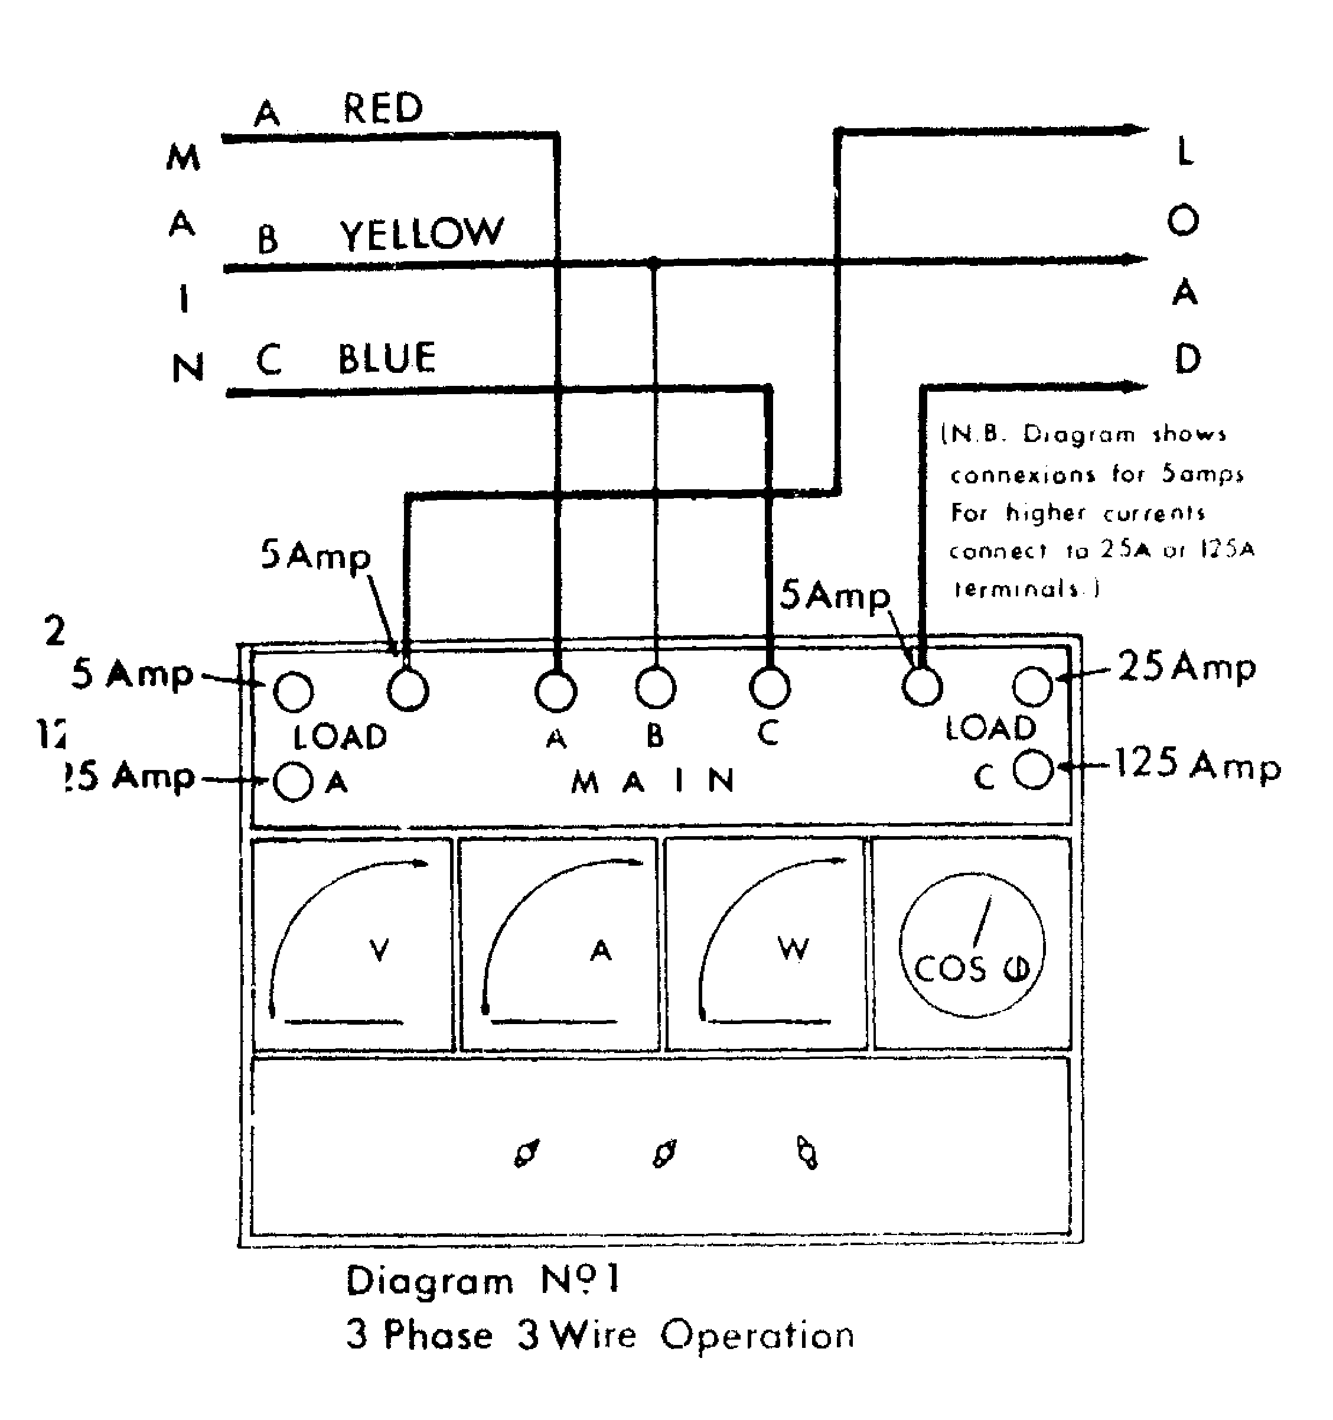

Power (in kilowatts) the Wattmeter scale reading must be multiplied by the scale factor according to the Tables printed on the left and right hand corners of the Instrument Panel, according to Voltage and Current ranges in Use.

Single Phase Circuits. Connect the I.P.A. according to Diagram 2 (for single phase operation). Current will be indicated with the Ammeter Phase Switch set in A or C positions. The same precautions are necessary for current polarity, voltage ranges, etc. Under Single Phase conditions, the Phase Sequence Indicator and the Power Factor Meter are inoperative.

Power Factor on single Phase Circuits may be calculated according to the equation printed under the single phase Wattmeter scale multiplying table see lower right hand corner of Instrument Panel.

3 Phase 4 Wire Circuits may be tested with the potential set-up as in 3 Phase 3 Wire provided that the load current in each Phase is equal. If there is an Out-of-Balance present, then each of the three phases must be tested as a Single Phase Circuit and the summation of the power in these will be the 3 Phase 4 Wire loading.

EXTENSION OF RANGES:

Where the Line Current exceeds 125 Amperes and/or the Phase-to Phase Voltage exceeds 600 Volts, the use of external Current and/or
Potential Transformers is necessary. By, means of these Transformers, the ranges may be extended almost indefinitely. (See Diagrams 3 and 4 for connections).

Current, Voltage and Power (KW) indications should be multiplied by the ratios of the Current and or Potential Transformers.

N.B. Current Transformers of S Amperes and Potential Transformers of 110 Volt Secondary Ratings must be used.
I

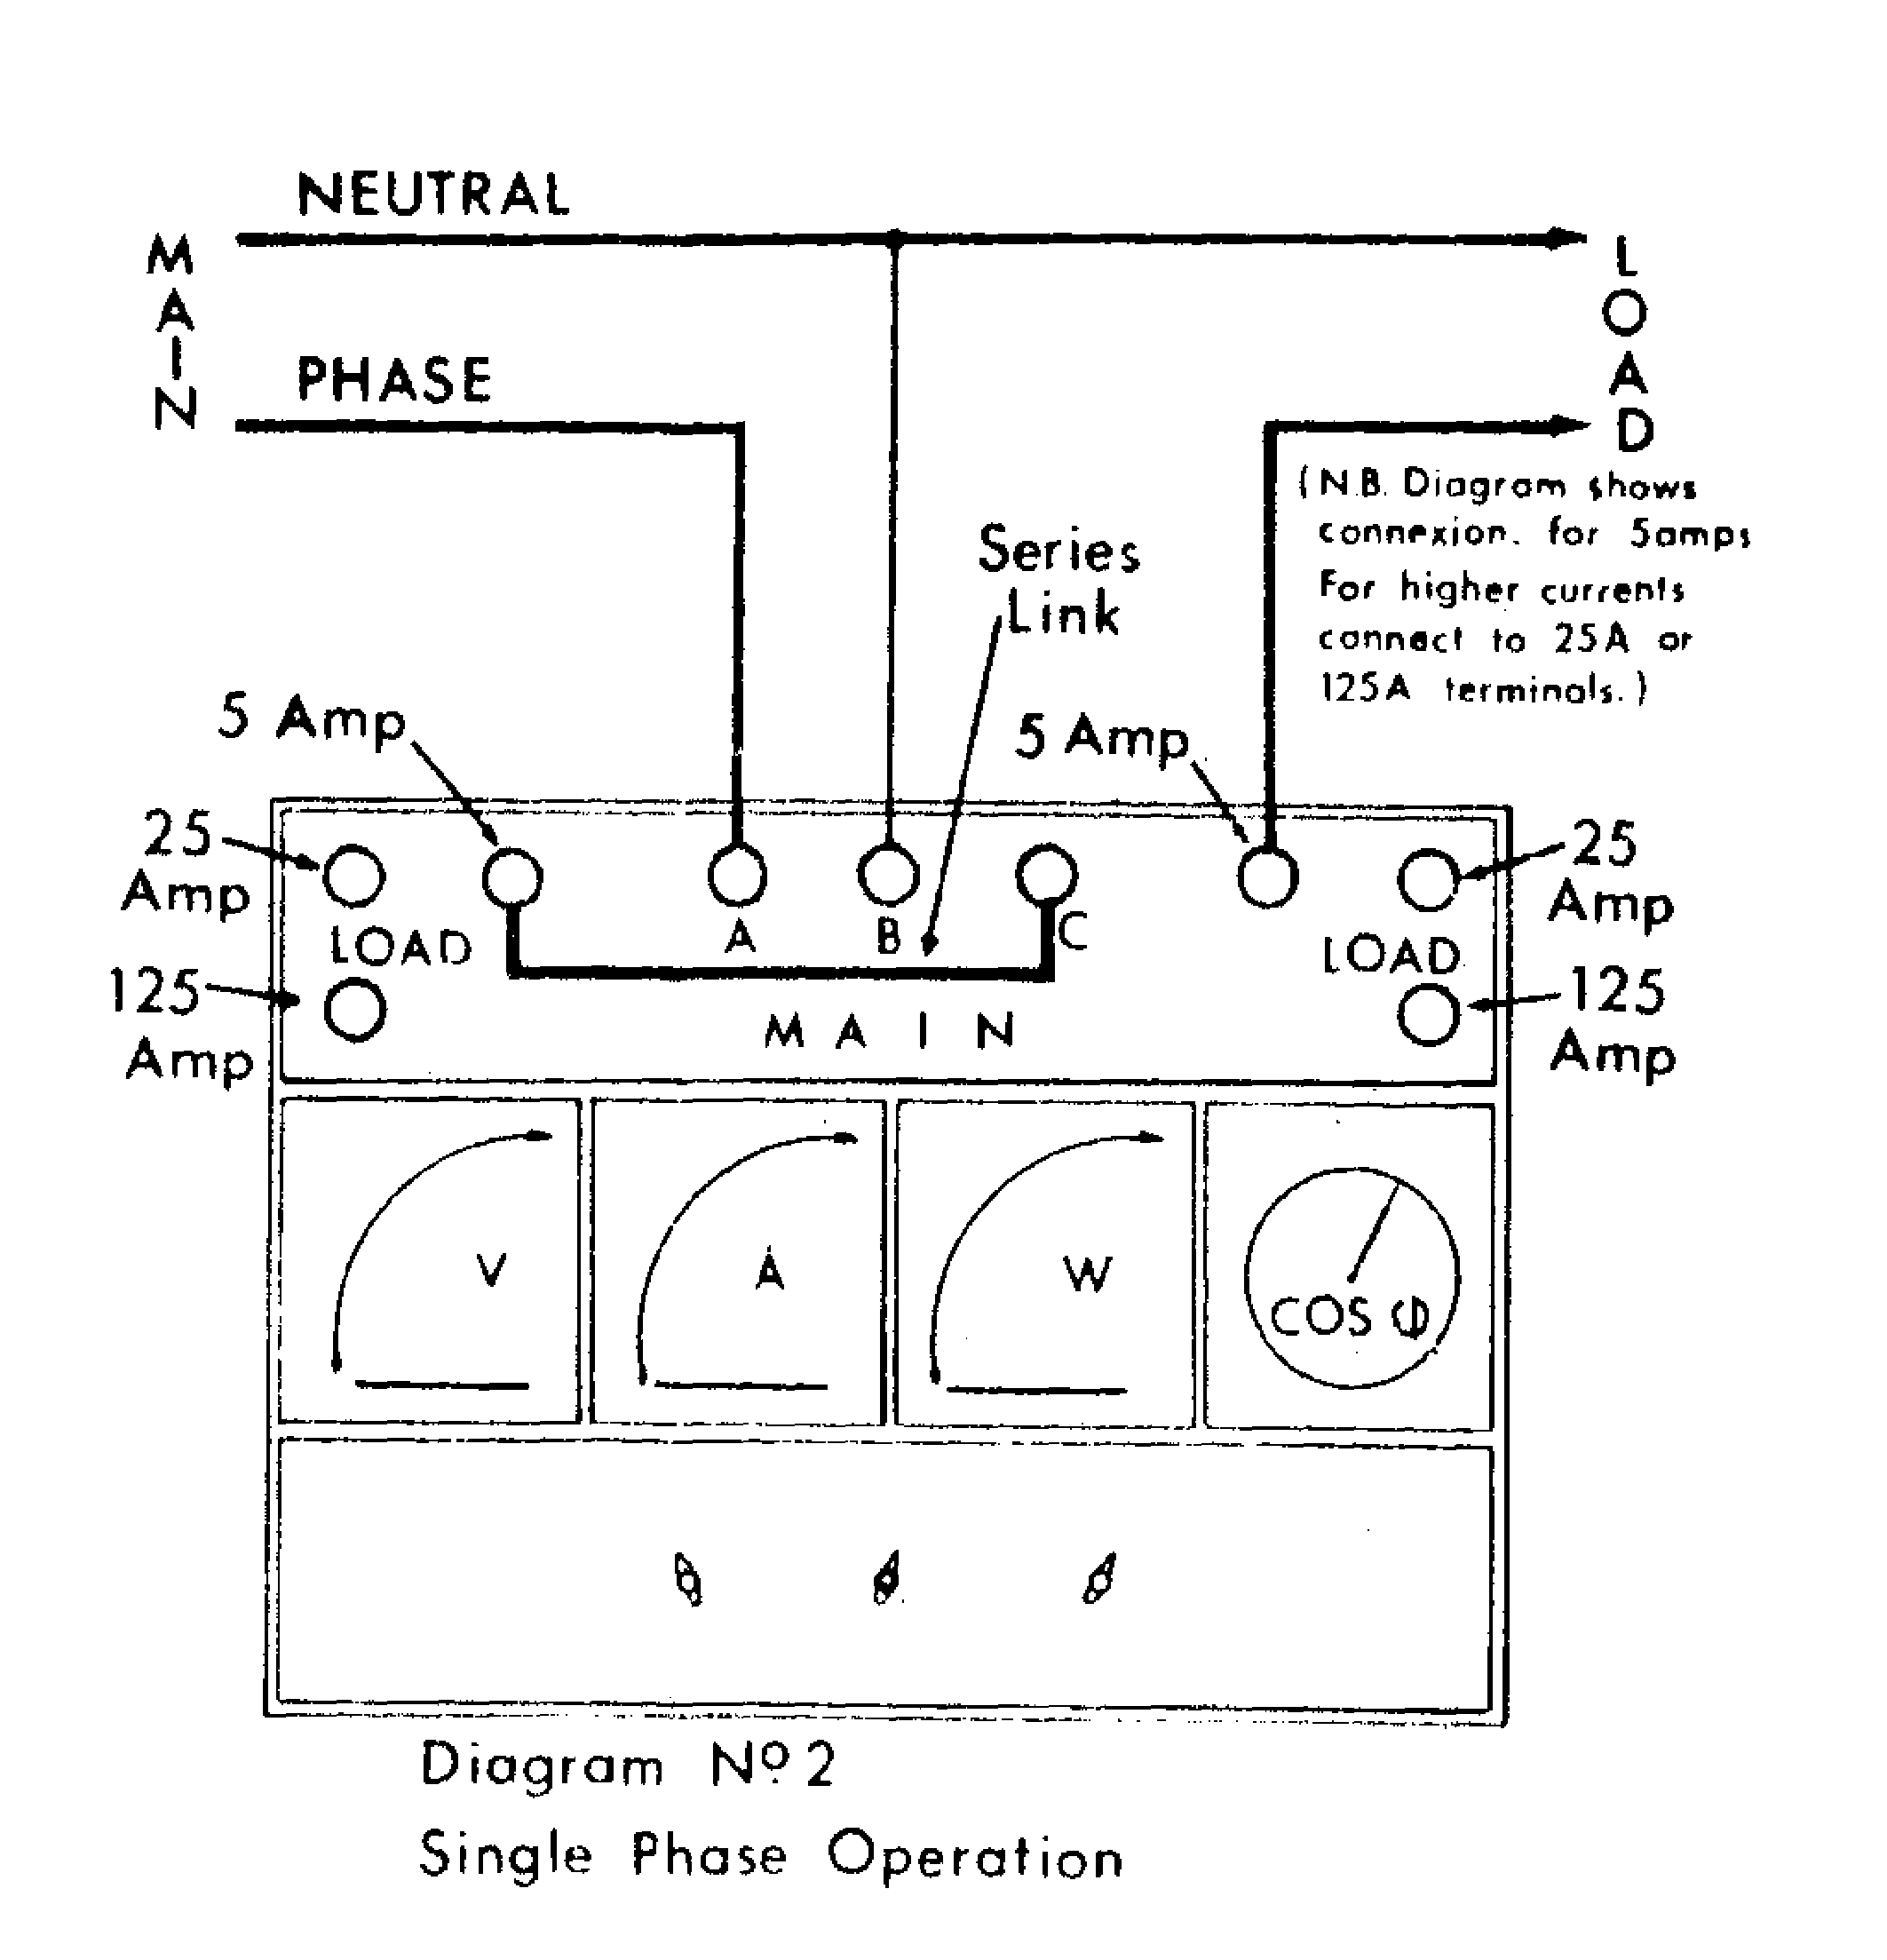

V.A. Burden imposed upon External Potential and Current Transformers is :

Potential 11.0 V.A./Ph. @110V. 50 C/S.
Current 90 V.A./Ph. @ 5A. 50C/S.

Phase Angle. The Power Factor Meter is calibrated with Phase Angle Scale printed in Red. This scale indicates the Electrical Degrees of Lag of the Current Vector (B Phase) behind the Voltage Vector.

OPERATING CURRENT OF A.C. MOTORS :

Approximately Full Load Current per Phase of A.C. Motors, assuming average at various Voltage values :-

Table B Single Phase Motors

H.P. | Voltage @ 50 C/S
H.P. | 200 V. | 220 V. | 240 V.
1  2  3  5 | 7.0 A.  12.0 A.  17.0 A.  28.0 A. | 6.6 A  11.0 A  16.0 A.  25.0 A. | 6.3 A  10.0 A  14.0 A  23.0 A

Table A 3 Phase Motors

H.P. | Voltage @ 50 C/S
H.P. | 415 V. | 440 V. | 550 V.
1  2  3  5  10  15  20  30  40  50  60  80  100 | 2.0 A.  3.5 A.  5.0 A.  8.0 A.  14.0 A.  21.0 A  27.0 A.  40 .0 A.  53.0 A.  66.0 A.  78.0 A.  103.0 A.  125.0 A. | 1.8 A.  3.0 A.  4.5 A.  7.0 A.  13.0 A.  20.0 A.  26.0 A.  38.0 A.  50.0 A.  62.0 A.  73.0 A.  97.0 A.  121.0 A. | 1.4 A.  2.5 A.  3.6 A.  5.8 A.  10.5 A.  16.0 A.  21.0 A.  30.0 A.  40.0 A.  50.0 A.  59.0 A.  77.5 A.  96.0 A.

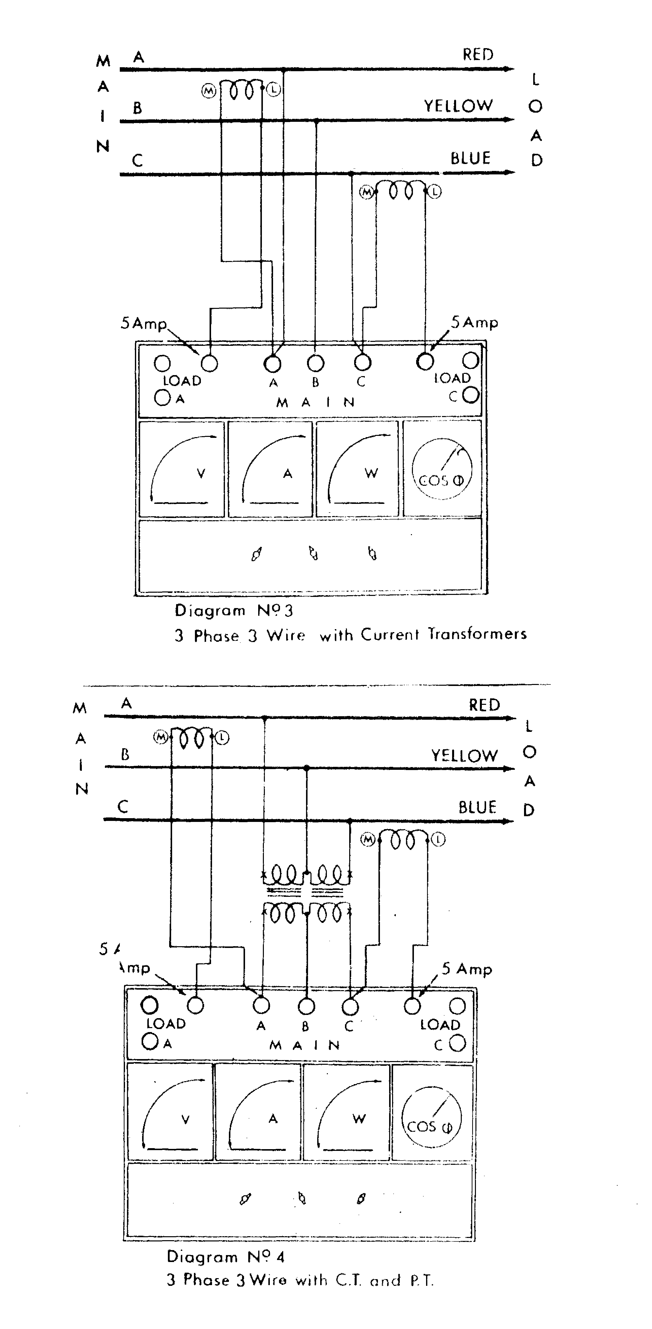

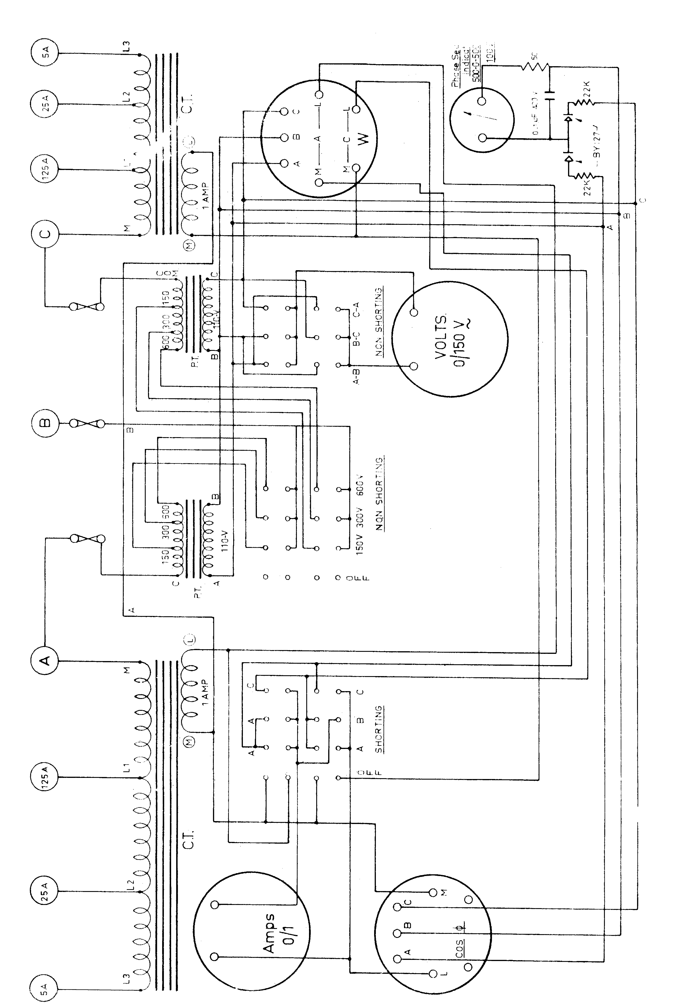

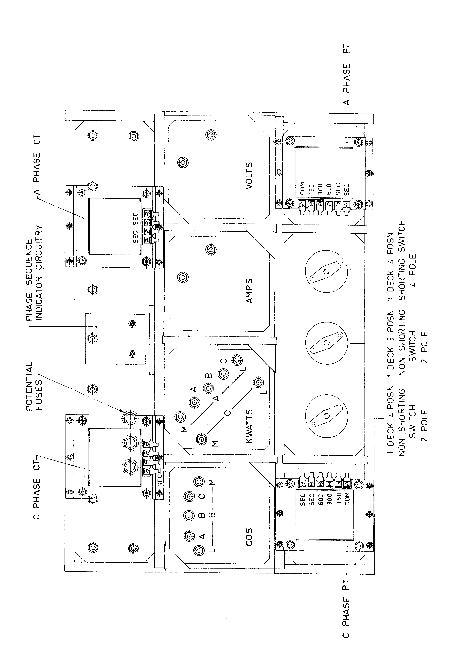

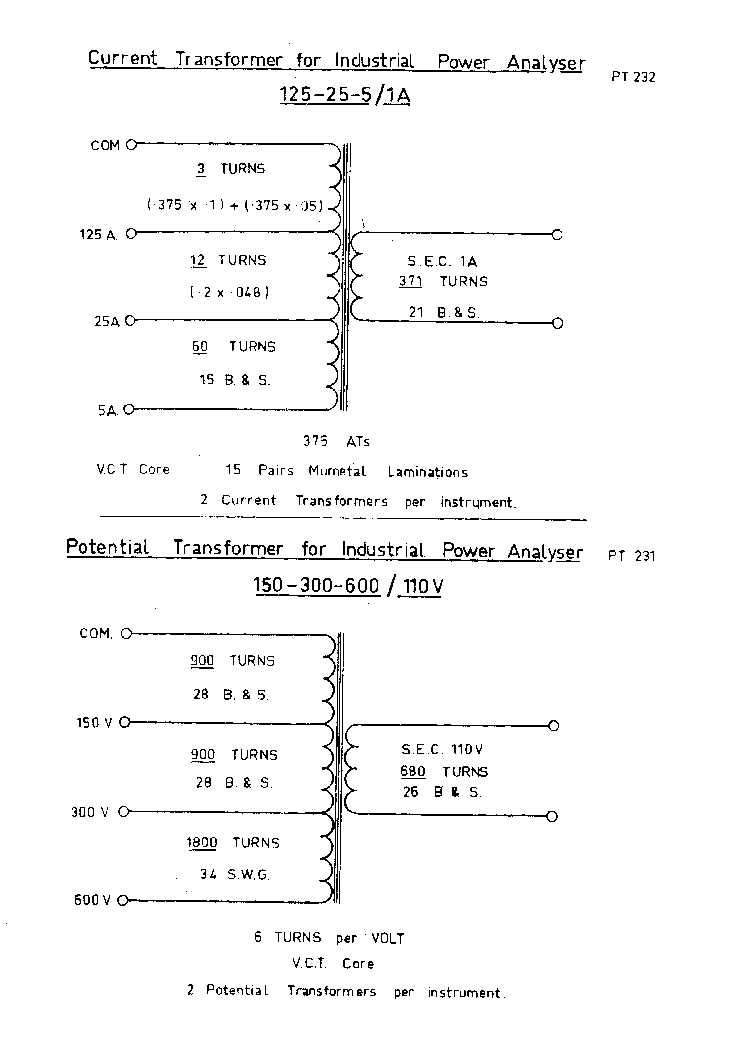

The deflection coils within the meter are peculiar to the particular instrument. Should any fault arise in these units, the complete meter should be returned to the manufacturer for repair. Following any repair and at intervals of not more than one year the calibration of the unit should be checked.

Replaceable Parts

Ammeter 536 Q. I.P.A.

Voltmeter 536 Q. I.P.A.

Wattmeter 536 Q. I.P.A.

Power Factor Meter 536 C.S. I.P.A.

Current Transformer V.C.T. I.P.A.

Potential Transformer V.C.T. I.P.A.

Phase Sequence Indicator 100 H. 100 V

Case D3964

Frame D3963/A

Front Panels D3965/A

Terminals RG 435

Switch Knobs KN 15

Switches – Amps Phase Selector B15 – 1 4 4

Volts Interphase B15 – 1 2 3

Potential Range B15 – 1 2 4

INDUSTRIAL POWER

ANALYSER



MADE IN AUSTRALIA BY

PATON ELECTRICAL PTY. LTYD.

ASHFIELD, N.S.W.

